**Chocolate Cake with Coffee**

[**https://res.cloudinary.com/dmgt77hiz/image/upload/v1730909802/Chocolate_Cake_with_Coffee_Recipe2_axnvri.jpg**](https://res.cloudinary.com/dmgt77hiz/image/upload/v1730909802/Chocolate_Cake_with_Coffee_Recipe2_axnvri.jpg)

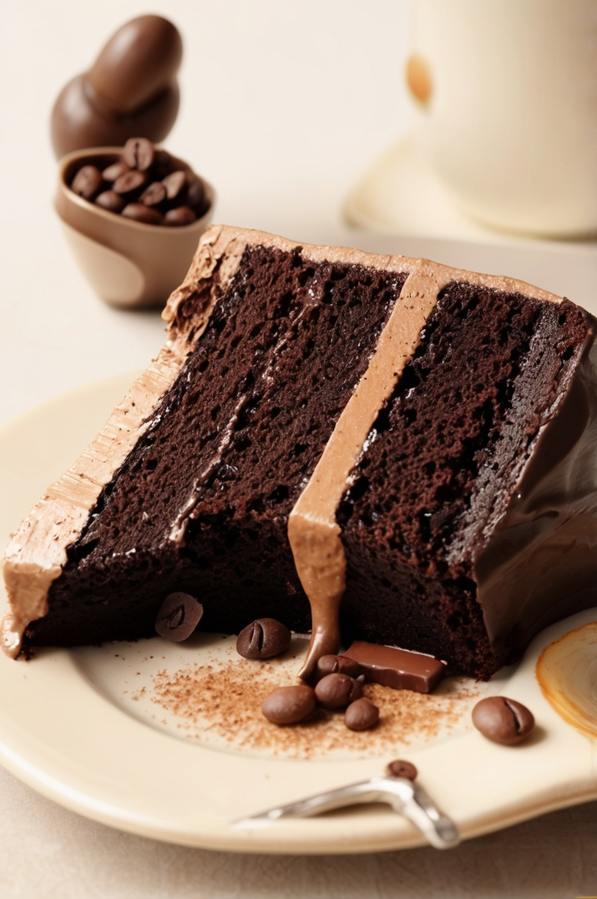

**Green Tea**

[**https://www.bing.com/images/search?view=detailV2&ccid=fpbNTc0%2f&id=FEBC9C815307AD9B068E37D4BE3728B1C43223B7&thid=OIP.fpbNTc0_5qQIQEEsZIzDzwHaEZ&mediaurl=https%3a%2f%2fstatic.india.com%2fwp-content%2fuploads%2f2018%2f01%2fTea.jpg&exph=415&expw=700&q=tea&simid=608006497752207932&FORM=IRPRST&ck=042BF941F0D0265E6F842017C43EFE89&selectedIndex=63&itb=0**](https://www.bing.com/images/search?view=detailV2&ccid=fpbNTc0%2f&id=FEBC9C815307AD9B068E37D4BE3728B1C43223B7&thid=OIP.fpbNTc0_5qQIQEEsZIzDzwHaEZ&mediaurl=https%3a%2f%2fstatic.india.com%2fwp-content%2fuploads%2f2018%2f01%2fTea.jpg&exph=415&expw=700&q=tea&simid=608006497752207932&FORM=IRPRST&ck=042BF941F0D0265E6F842017C43EFE89&selectedIndex=63&itb=0)



#### [**https://th.bing.com/th/id/R.c6ce4ef394413869bb06283db819c628?rik=dsxV%2b0CdNNsOmA&riu=http%3a%2f%2fsfsco.net%2fwp-content%2fuploads%2f2016%2f04%2f6140989632_1c8066563d_b.jpg&ehk=uLWHPAmp35gMcoEmYFZKjh1wg8vpPdCZcGGtPh72e7w%3d&risl=&pid=ImgRaw&r=0**](https://th.bing.com/th/id/R.c6ce4ef394413869bb06283db819c628?rik=dsxV%2b0CdNNsOmA&riu=http%3a%2f%2fsfsco.net%2fwp-content%2fuploads%2f2016%2f04%2f6140989632_1c8066563d_b.jpg&ehk=uLWHPAmp35gMcoEmYFZKjh1wg8vpPdCZcGGtPh72e7w%3d&risl=&pid=ImgRaw&r=0)

#### [**https://png.pngitem.com/pimgs/s/530-5303951_sales-manager-woman-png-transparent-png.png**](https://png.pngitem.com/pimgs/s/530-5303951_sales-manager-woman-png-transparent-png.png)

#### [**https://www.trianglepartners.co.uk/wp-content/uploads/2014/03/cardinal_team_4-700x700.jpg**](https://www.trianglepartners.co.uk/wp-content/uploads/2014/03/cardinal_team_4-700x700.jpg)

#### **Signature Treats**

* **Classic Chocolate Cake  
  A rich and moist chocolate cake, perfect for any occasion.  
  *Price: $5.50 per slice / $30 for a whole cake*** [***https://bing.com/th?id=OSK.6436c12256d8444a3201d3e2411be1bc***](https://bing.com/th?id=OSK.6436c12256d8444a3201d3e2411be1bc)

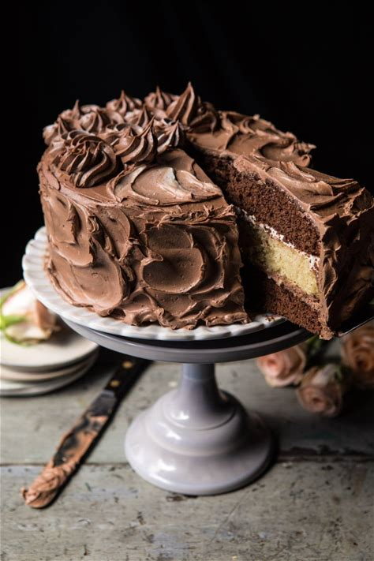

* **Decadent Chocolate Squares  
  Bite-sized pieces of pure chocolate indulgence.  
  *Price: $2.00 each / $10 for a box of 6*** [***https://myislandbistrokitchen.com/wp-content/uploads/2015/07/DSC_0367.jpg***](https://myislandbistrokitchen.com/wp-content/uploads/2015/07/DSC_0367.jpg)

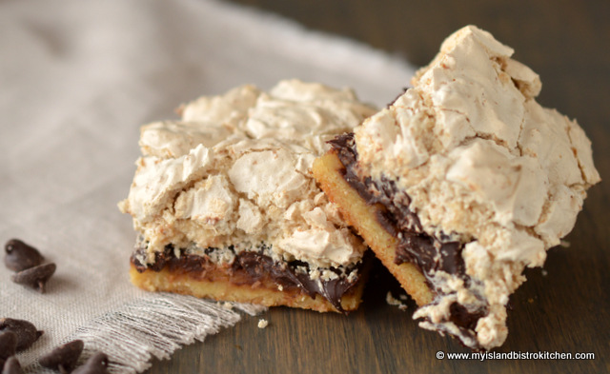

* **Chocolate-Dipped Strawberries  
  Juicy strawberries coated in smooth chocolate.  
  *Price: $1.50 each / $8 for a box of 6*** [***https://www.bakemeawish.com/images/products/pr/1000/1469_1000.jpg***](https://www.bakemeawish.com/images/products/pr/1000/1469_1000.jpg)



* **ChocoSlip Brownies  
  Fudgy, chewy brownies loaded with chocolate chunks.  
  *Price: $3.00 each / $15 for a box of 6*** [***https://www.recipetineats.com/wp-content/uploads/2020/03/Brownies_0-SQ.jpg?resize=85***](https://www.recipetineats.com/wp-content/uploads/2020/03/Brownies_0-SQ.jpg?resize=85)

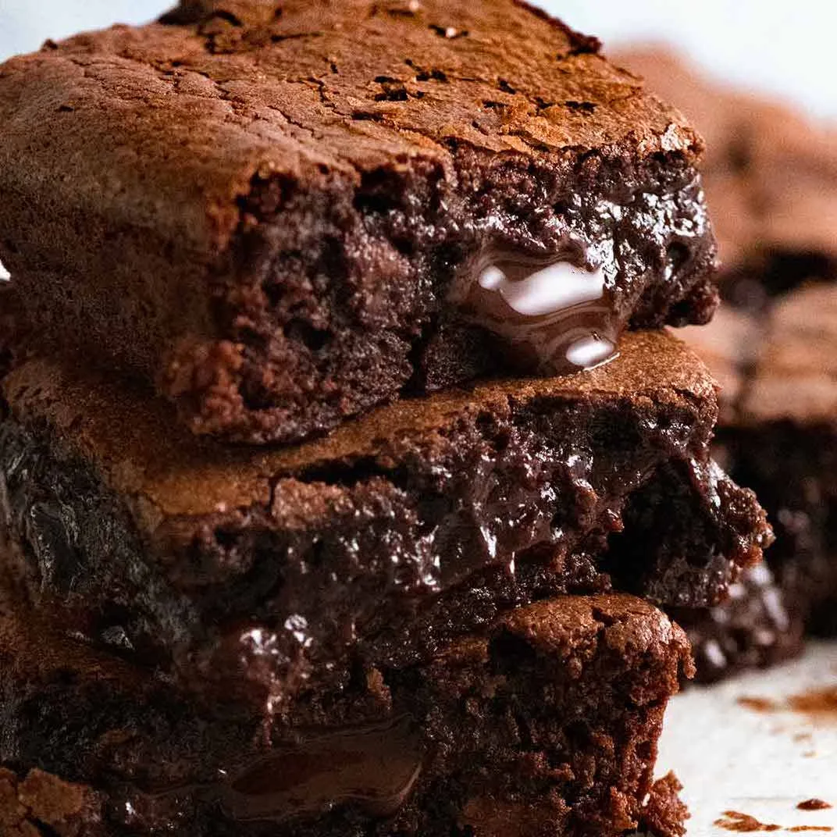

* **Mini Chocolate Cheesecakes  
  Creamy cheesecakes with a chocolatey twist.  
  *Price: $4.50 each*** [***https://bing.com/th?id=OSK.7b202299943cadbf257c097297aa5625***](https://bing.com/th?id=OSK.7b202299943cadbf257c097297aa5625)

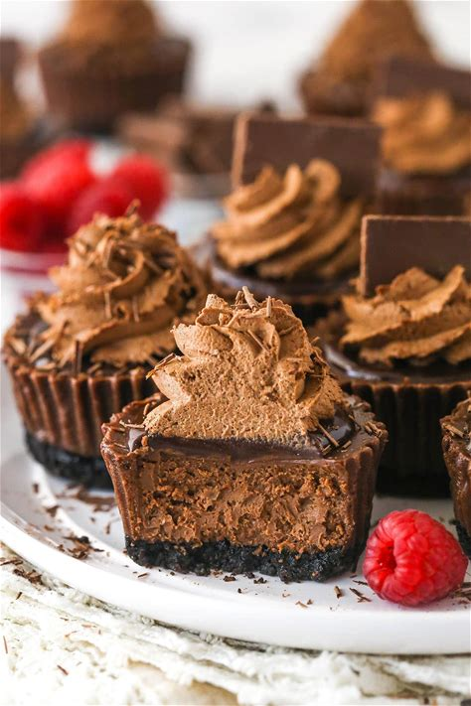

#### **Take-Away Chocolate**

**Artisan Chocolate Bars  
Available in dark, milk, or white chocolate.  
*Price: $5.00 each*** [***https://thumbs.dreamstime.com/b/artisan-handmade-chocolate-bars-artisan-handmade-chocolate-bars-dried-fruits-105392037.jpg***](https://thumbs.dreamstime.com/b/artisan-handmade-chocolate-bars-artisan-handmade-chocolate-bars-dried-fruits-105392037.jpg)

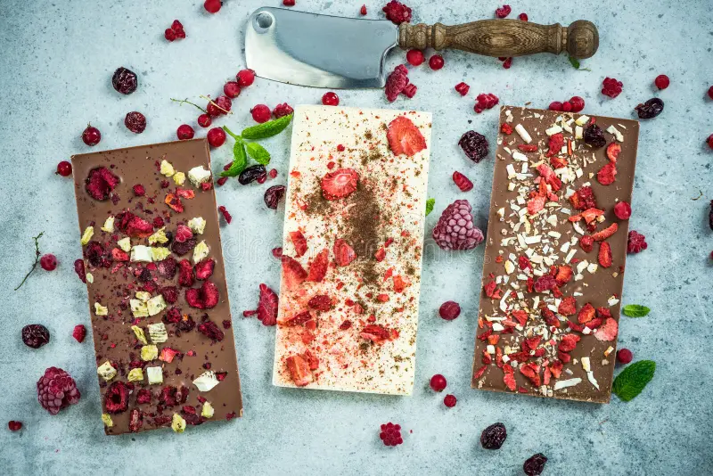

**Chocolate Truffle Box  
An assortment of hand-rolled chocolate truffles.  
*Price: $14 for a box of 9*** [***https://th.bing.com/th/id/OIP.rpImO84EBRPz9g7Q7fe3TAHaGw?rs=1&pid=ImgDetMain***](https://th.bing.com/th/id/OIP.rpImO84EBRPz9g7Q7fe3TAHaGw?rs=1&pid=ImgDetMain)

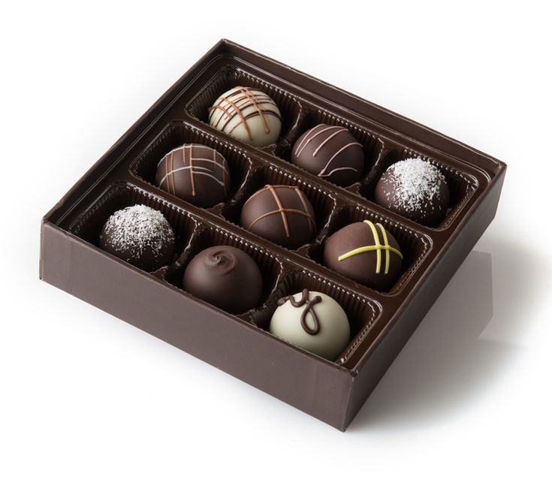

**ChocoSlip Signature Chocolate Box  
A premium selection of chocolates, perfect for gifting.  
*Price: $20 for a box of 12*** [***https://littlecocoa.com.au/wp-content/uploads/2022/08/signature12pc-7-of-1-800x800.jpg***](https://littlecocoa.com.au/wp-content/uploads/2022/08/signature12pc-7-of-1-800x800.jpg)

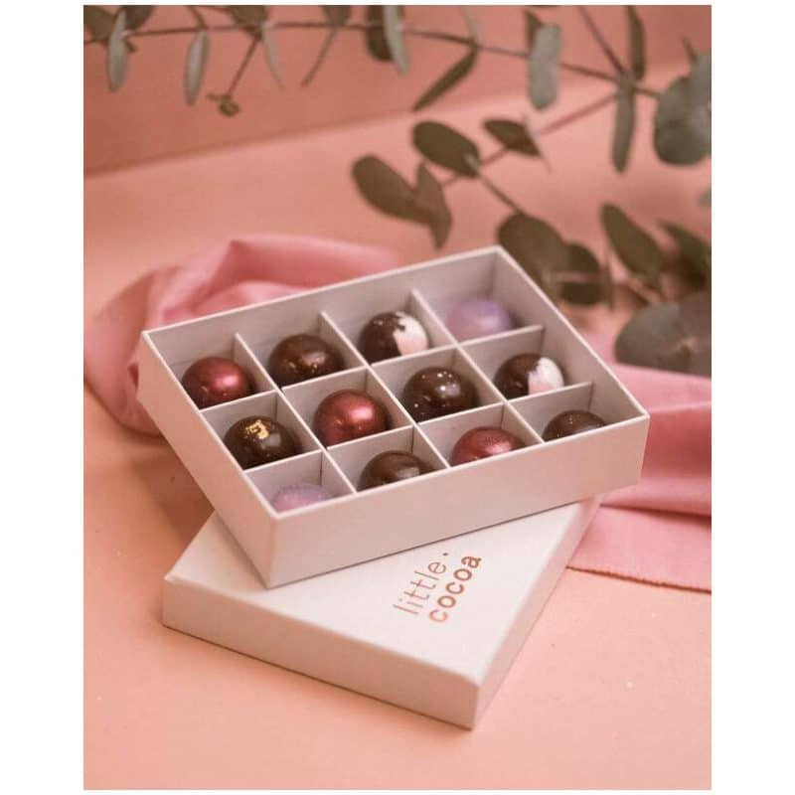

#### **Hot Beverages**

* **Freshly Brewed Coffee  
  Bold and aromatic, served hot or iced.  
  *Price: $3.00 (Small) / $4.00 (Large)*** [***https://th.bing.com/th/id/OIP.jI9SPrQ5BS7RGapGssChfwHaEu?rs=1&pid=ImgDetMain***](https://th.bing.com/th/id/OIP.jI9SPrQ5BS7RGapGssChfwHaEu?rs=1&pid=ImgDetMain)



* **Premium Tea Selection  
  Choose from green, black, herbal, or chai blends.  
  *Price: $3.00 (Small) / $4.00 (Large)***
  + **Green Tea** [**https://www.bing.com/images/search?view=detailV2&ccid=fpbNTc0%2f&id=FEBC9C815307AD9B068E37D4BE3728B1C43223B7&thid=OIP.fpbNTc0_5qQIQEEsZIzDzwHaEZ&mediaurl=https%3a%2f%2fstatic.india.com%2fwp-content%2fuploads%2f2018%2f01%2fTea.jpg&exph=415&expw=700&q=tea&simid=608006497752207932&FORM=IRPRST&ck=042BF941F0D0265E6F842017C43EFE89&selectedIndex=63&itb=0**](https://www.bing.com/images/search?view=detailV2&ccid=fpbNTc0%2f&id=FEBC9C815307AD9B068E37D4BE3728B1C43223B7&thid=OIP.fpbNTc0_5qQIQEEsZIzDzwHaEZ&mediaurl=https%3a%2f%2fstatic.india.com%2fwp-content%2fuploads%2f2018%2f01%2fTea.jpg&exph=415&expw=700&q=tea&simid=608006497752207932&FORM=IRPRST&ck=042BF941F0D0265E6F842017C43EFE89&selectedIndex=63&itb=0)



* + **Herbal Tea** [**https://th.bing.com/th/id/OIP.wetrj9qgNuPQ1gfs8S--1gHaEK?w=330&h=186&c=7&r=0&o=5&dpr=1.5&pid=1.7**](https://th.bing.com/th/id/OIP.wetrj9qgNuPQ1gfs8S--1gHaEK?w=330&h=186&c=7&r=0&o=5&dpr=1.5&pid=1.7)



* + **Black Tea** [**https://miro.medium.com/v2/resize:fit:1200/0*zELTSe_q5h_stSGk.jpg**](https://miro.medium.com/v2/resize:fit:1200/0*zELTSe_q5h_stSGk.jpg)



* **Hot Chocolate  
  Rich and velvety with a hint of whipped cream on top.  
  *Price: $4.00***

[***https://assets.dmagstatic.com/wp-content/uploads/media/4/hot_chocolate_taste_test.jpg***](https://assets.dmagstatic.com/wp-content/uploads/media/4/hot_chocolate_taste_test.jpg)

* **Mocha Delight  
  A perfect blend of coffee and chocolate.  
  *Price: $4.50***

[***https://img.freepik.com/premium-photo/top-view-minimalistic-isolated-mocha-delight_759095-160295.jpg***](https://img.freepik.com/premium-photo/top-view-minimalistic-isolated-mocha-delight_759095-160295.jpg)

#### **Signature Pairing Deals**

* **Chocolate Cake + Coffee or Tea  
  *Price: $7.50***
* **Brownie + Hot Chocolate  
  *Price: $6.50***